Sustainable Development Goals
Exploratory Data Analysis
Name: Rasil Kodah

Business Problem
The 2030 Agenda for Sustainable Development is a global plan adopted by all UN Member States in 2015 and outlines 17 Sustainable Development Goals (SDGs) aimed at achieving peace, prosperity, and environmental sustainability for all regions over the world.
The SDGs are built upon decades of prior work and research, including Agenda 21 (1992), a comprehensive plan for sustainable development adopted at the Earth Summit, Johannesburg Declaration (2002), which consists of reaffirmed commitments to poverty eradication and environmental protection, Rio+20 (2012), which launched the process to develop the SDGs, and Millennium Development Goals (MDGs) which contains eight goals to reduce extreme poverty by 2015.
As a data analyst at the United Nations working in the department of economic and social affairs, your primary responsibility is to report and evaluate the global progress on the Sustainable Development Goals (SDGs) focusing on identifying trends and disparities, presenting actionable insights.
You are specialized in sustainable development and global affairs and have been tasked to monitor the SDG progress of individual countries in the following deliverables:
- Top Performing Nations: Identifying countries that show exceptional progress, specifying the goals they are excelling in.
- Struggling Nations: Recognizing countries that are lagging behind, pinpointing the goals where they are struggling compared with the first category.
- Reasons for Disparities: Investigating factors contributing to their success or struggles, such as policies, economic stability, geographic challenges, or technological or educational advancements.
A visual representation of the findings is required to compare the leading countries in SDG and the struggling countries by means of the nation’s resources, economy, policies, and overall prioritization of sustainable development. By analyzing this data, the UN will be able to designate each country’s needs and priorities so they can advance in the sustainable goal for cleaner energy and a safer future.

Business Impact
Investigating this dataset will help allocate resources more effectively by identifying patterns and trends. This will allow for machine-learning based time-series forecasting which relies on the historical records and the performed prediction analysis. Exploring the data will also define where the strategies succeed in some regions and fail in other regions, giving an opportunity for more customized policies.
Cultivating these results will aid in providing a more thorough and specified action plan for countries to progress in their development goals depending on their own conditions and circumstances which will encourage cooperation and coordination between nations to achieve the shared objective for a more sustainable environment.

Dataset(s)
Primary
File Name: sustainable_development_report_2023.csv
Description: Sustainable Development Report of 2023
Dataset Details: 167 rows & 21 columns
Size: 32 KB
Source: Kaggle- Dataset

Secondary
File Name: sdg_index_2000-2022.csv
Description: sustainability scores and performance on individual SDGs (2000-2022)
Dataset Details: 4141 rows & 21 columns
Size: 428 KB
Source: Kaggle- Dataset

Additional
File Name: global-data-on-sustainable-energy
Description: sustainable energy indicators across all countries from 2000 to 2020
Dataset Details: 3650 rows & 20 columns
Size: 502 KB
Source: Kaggle-Additional Dataset

Target Features
Primary and secondary datasets:
- country_code: Country code.
- country: Country name.
- region: the region in which the country belongs to
- overall_score: The overall sustainability (SDG index) score of the country.
- year: Year of the data.
- sdg_index_score: Overall SDG index score.
- goal_1_score to goal_17_score: Individual scores for each of the 17 SDGs.
Additional datasets:
- Entity: The name of the country or region for which the data is reported.
- Year: The year for which the data is reported, ranging from 2000 to 2020.
- Access to electricity (% of population): The percentage of population with access to electricity.
- Access to clean fuels for cooking (% of population): The percentage of the population with primary reliance on clean fuels.
- Renewable-electricity-generating-capacity-per-capita: Installed Renewable energy capacity per person
- Financial flows to developing countries (US $): Aid and assistance from developed countries for clean energy projects.
- Renewable energy share in total final energy consumption (%): Percentage of renewable energy in final energy consumption.
- Electricity from fossil fuels (TWh): Electricity generated from fossil fuels (coal, oil, gas) in terawatt-hours.
- Electricity from nuclear (TWh): Electricity generated from nuclear power in terawatt-hours.
- Electricity from renewables (TWh): Electricity generated from renewable sources (hydro, solar, wind, etc.) in terawatt-hours.
- Low-carbon electricity (% electricity): Percentage of electricity from low-carbon sources (nuclear and renewables).
- Primary energy consumption per capita (kWh/person): Energy consumption per person in kilowatt-hours.
- Energy intensity level of primary energy (MJ/$2011 PPP GDP): Energy use per unit of GDP at purchasing power parity.
- Value_co2_emissions (metric tons per capita): Carbon dioxide emissions per person in metric tons.
- Renewables (% equivalent primary energy): Equivalent primary energy that is derived from renewable sources.
- GDP growth (annual %): Annual GDP growth rate based on constant local currency.
- GDP per capita: Gross domestic product per person.
- Density (P/km2): Population density in persons per square kilometer.
- Land Area (km2): Total land area in square kilometers.
- Latitude: Latitude of the country's centroid in decimal degrees.
- Longitude: Longitude of the country's centroid in decimal degrees.

Analysis
Analysis 1: Number of Rows and Columns - Excel
Merging the data together helped recognize which columns needed to be in the others dataset. The “region” column was added from the primary dataset to the secondary dataset in order to group the countries by region for a more generalized overview on the data. VLOOKUP was used on Excel to further clean the data before uploading it to my drive file and use it as a path file to use Python for further EDA investigations. This makes the total columns for the secondary data increase from 21 to 22 columns.
Analysis 2: Data Preparation - Python
Python was decided to be used for its versatile functions and its benefits in data analysis and initial visualization of charts. The data was uploaded to the rive file and saved as a csv file, as mentioned previously, and imported into python as a data frame. Pandas and Matplotlib were used in this phase to perform the analysis functions on the data frame and be able to plot the required charts for the EDA to be represented visually.
Analysis 3: Primary Dataset - 2023
The primary data represents the overall SDG score (average value of all 17 goals) for each participating country, which are 167 countries in total. By plotting the overall scores and frequency, it was noticed that over 25 countries scored above 70 and around 20 countries scored above 80. This gives a positive indication to the future of the sustainable development goals in the year of 2023. The statistics also showed a negative skewness to the overall scores of each country that year, which can be translated to most of the countries leaning towards higher scores, hence, a more sustainable environment, specifically for developed countries.
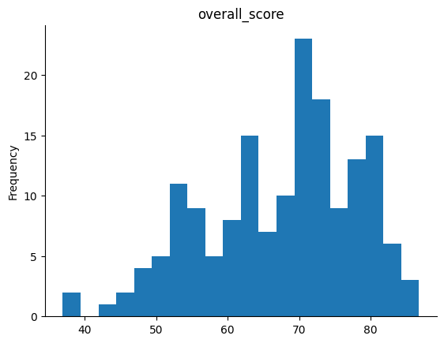
Figure 1: Overall SDG Score of 2023 - Histogram

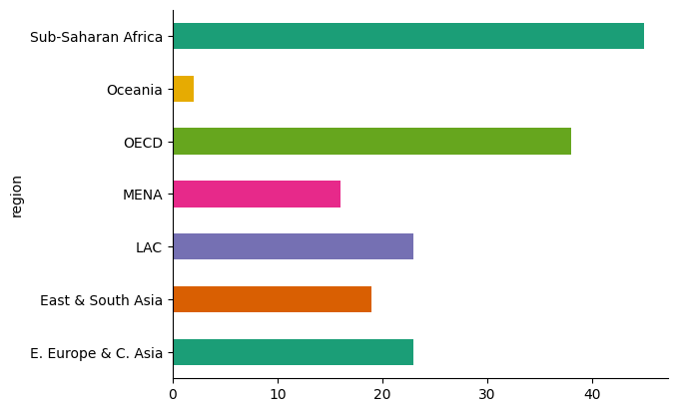
Figure 2: Number of Countries in Each Region

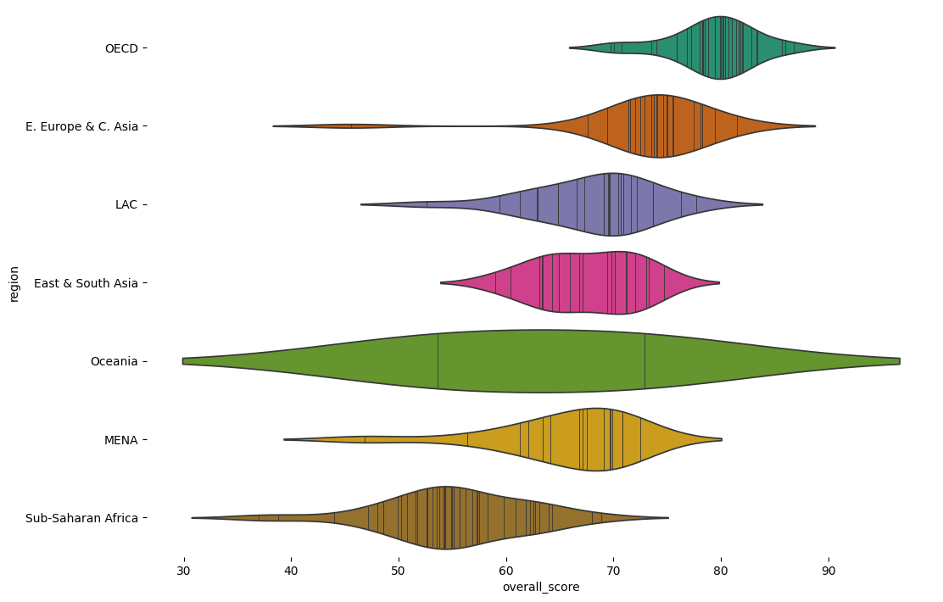
Figure 3: World Regions and Overall SDG Scores for the year 2023
Figures 1 through 3 display the initial visualizations for the overall scores of each region. Figure 1 shows the negative skew of the overall scores in 2023. The next figure represents how countries are in each region so the statistics in further phases can be based in the number of countries and on each disparate goal. And lastly, the third figure represents the density of the countries’ scores in their respective regions. These figures were generated using Matplotlib in Python.
Analysis 4: Secondary Dataset – 2000-2022
The secondary data represents the SDG index scores for each country from years 2000 up to 2022. The data was sorted by year and SDG index score and the expected result was to have a similar skew to the primary (2023) data, and indeed it has despite the close parameters (mode, median, and mean) which indicates positive progression of efforts towards clean energy and a more inclusive and just society. There were some countries that were not improving as anticipated over the years. For example, countries in regions like the Sub-Saharan Africa’s Ghana, Mozambique, and Mauritius, MENA’s Yemen, and Oceania’s Papua New Guinea, have been in a steady state for 22 years; neither improving nor reclining, struggling to achieve the sustainable goals and implement them into their respective nations.
The additional dataset will be used as metadata for all UN member countries in order to evaluate the reasons behind the decline or incline of sustainable energy.

Conclusion
In this phase, the data was prepared to be uploaded to Colab and Python was used to perform the exploratory data analysis (EDA). The main conclusions can be summarized from the analysis section that over 50 countries from 167 have been seriously implementing sustainable strategies to make their communities more inclusive and environmentally safe. These were mostly targeted in regions that are a member country of the OECD or E. Europe and C. Asia, which are considered advanced and stable countries. whereas the countries that scored low were generally from developing countries. Moreover, the general trend is 10% - 20% increase in both SDG index score and overall score, indicating a majority of upwards scaling towards achieving these goals.

The following link provides the python code and all the results obtained from the analysis phase: SDG EDA - Google Colab

